Lab 3a

D0011E

# One-bit full adder

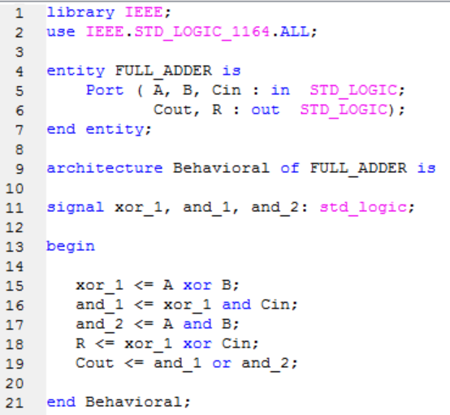

# 4-bit adder

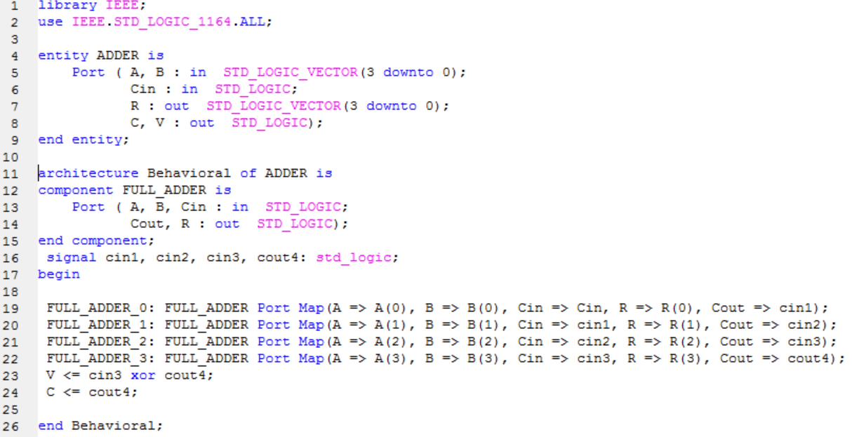

# 4-bit add/sub unit

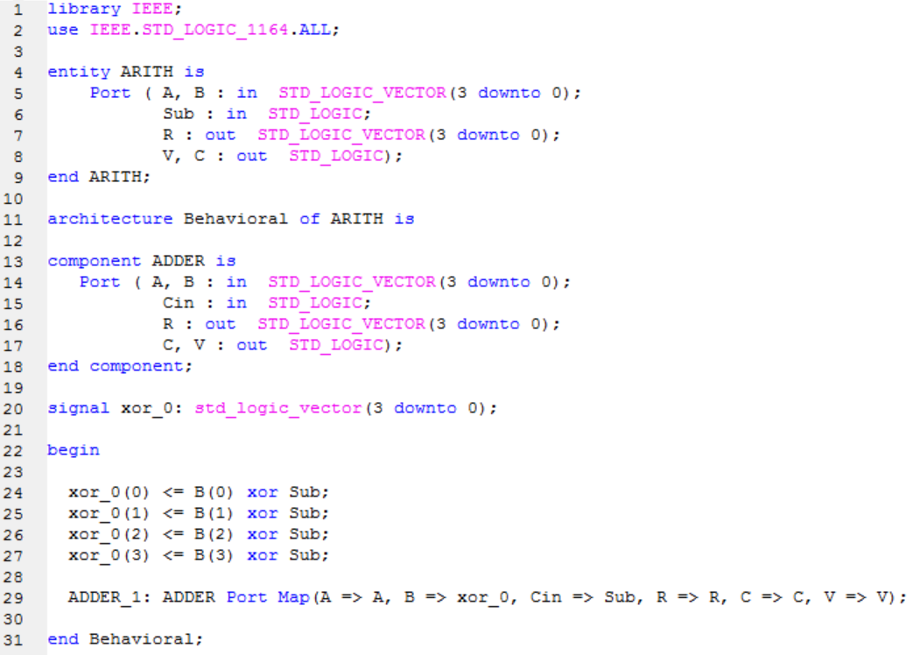

|  |  |  |  |  |
| --- | --- | --- | --- | --- |
| UNSIGNED A | UNSIGNED B | UNSIGNED R | OVERFLOW V | CARRY C |
| 0100 (4) | 0011 (3) | 0111 (7) | 0 | 0 |
| 0111 (7) | 0010 (2) | 1001 (9) | 1 | 0 |
| 1000 (8) | 1000 (8) | 0000 (0) | 1 | 1 |
| 1100 (12) | 1100 (12) | 1000 (8) | 0 | 1 |

# The tables of the 4-bit add/sub unit

4 + 3 = 7 which is correct and therefore we should not get an overflow or a carry, which we did not.

7 + 2 = 9 which is correct, but we got an overflow which we should not get since the answer is correct.

8 + 8 = 0 which is incorrect because 8 + 8 = 16, therefore we should get an overflow and a carry since 16 is 100002 therefore the overflow and carry is correct.

12 + 12 = 8 which is incorrect because 12 + 12 = 24, therefore we should get an overflow and a carry since 24 is 110002 therefore the carry is correct but we did not get an overflow so the overflow is incorrect.

Since the overflow is not always one when the addition is incorrect we can not trust it, but the carry is one when the addition is correct, therefore the carry can be used to detect errors.

|  |  |  |  |  |
| --- | --- | --- | --- | --- |
| SIGNED A | SIGNED B | SIGNED R | OVERFLOW V | CARRY C |
| 0100 (4) | 0011 (3) | 0111 (7) | 0 | 0 |
| 0110 (7) | 0010 (2) | 1001 (-7) | 1 | 0 |
| 0111 (7) | 0010 (2) | 0101 (5) | 0 | 1 |
| 0000 (0) | 1000 (-8) | 1000 (-8) | 1 | 0 |

4 + 3 = 7 which is correct and therefore we should not get an overflow or a carry, which we did not.

7 + 2 = -7 which is incorrect because 7 + 2 = 9, therefore we should get an overflow but not a carry since 9 is usually written as 10012 but in two’s complement that equals to -7. Therefore, the overflow and carry is correct.

7-2 = 5 which is correct and since -2 is 11102 then the third and fourth columns have a carry, which means that the overflow is zero and the carry is one, therefore the overflow and carry is correct.

0-(-8) = -8 which is incorrect since 0-(-8) = 8. Since -8 = 10002 then we get 01112 when we invert it, then when we add 1 to the inverted number we get 10002 which means that the third carry gets a one and the fourth carry gets a zero, therefore we get an overflow.

The overflow is one when the addition is incorrect therefore it can be used to detect errors and the carry is only one when the fourth carry is one which does not mean that the answer is incorrect.

# The test bench

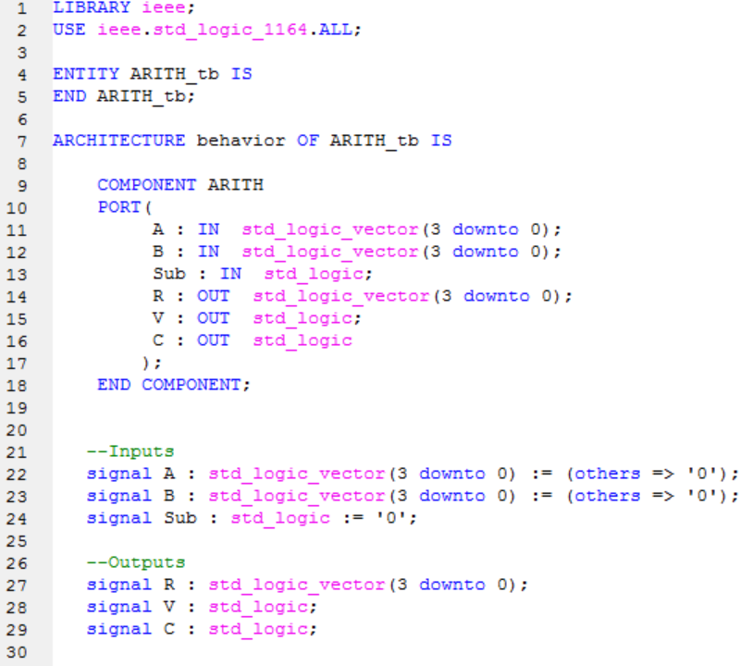

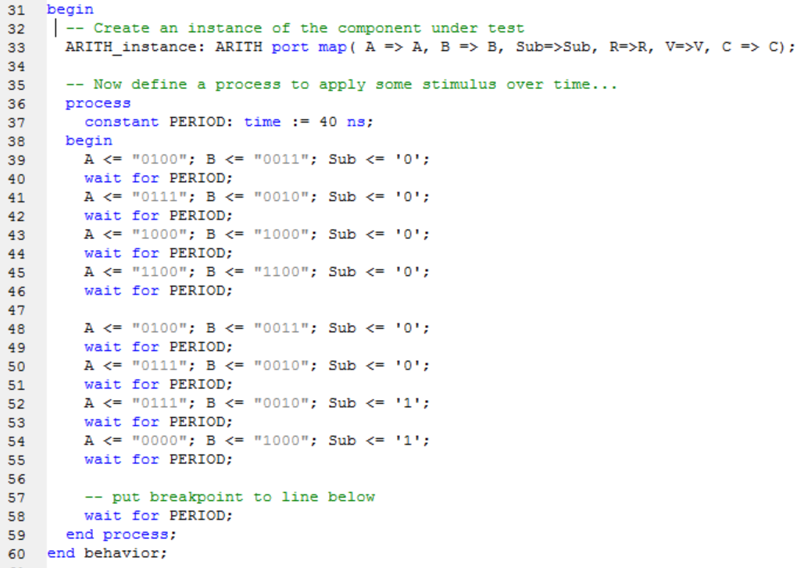

# 4-bit logic unit

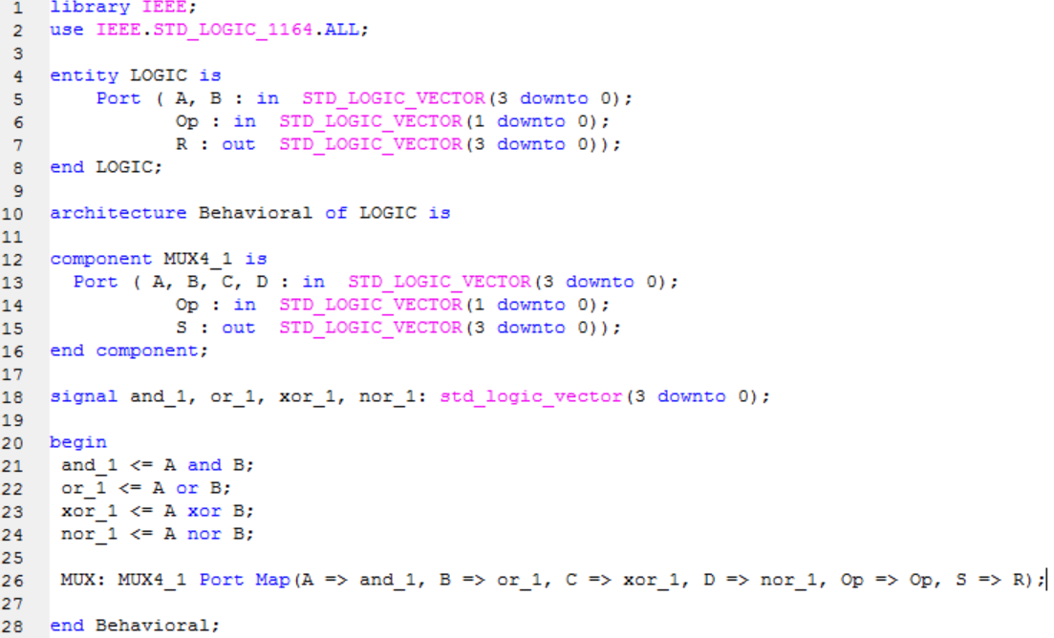

The multiplexer:

